Introduction to Jupiter 2
Global Use: Internationalization 2
Development of Jupiter 2
Data Storage 3
Adding / Editing / Deleting Records 4
Add a Record 4
Person 5
Person: Names 5
English 5
Hispanic 6
Arabic 7
Alias 8
Person: Gender 9
Person: Race 10
White 10
Black 10
Hispanic 10
Indian 10
Asian 10
Unknown 10
Person: Date of Birth 11
Organization 11
Event 12
Date of the Event 12
Event Title 12
Event Description 12
Address 13
Country 13
Street 13
City 13
State 13
Zip code 13
Phone 14
Phone Call 14
Note 14
Graph 15
Report 16

Introduction to Jupiter

Jupiter is a windows-based Link Analysis software application. Jupiter is intended for use by Law Enforcement or other Government agencies that are responsible for investigating, tracking, and/or prosecuting cases involving complex relationships. Jupiter stores relationships between the following entities:

- Persons
- Organizations
- Addresses
- Events
- Phones and Phone Calls
- Notes

The relationships or Links between these entities are presented to the user by either a Graph or in a Report.

Link analysis is the process of consolidating and organizing relational data and presenting the data into meaningful graphical representations which depict patterns, associations and relationships. In conducting complex investigations, link analysis can play an important role in identifying key aspects of an investigation.

Global Use: Internationalization

Jupiter is designed to be used globally. Through the use of text-based .properties files or Resource Bundles, Jupiter can be configured for use in different languages.

For example, strings representing messages displayed in the application. The idea is to load a specific bundle of resources, based on a particular locale. The locale is derived from the host computer. Jupiter loads the appropriate Resource Bundle based on the locale of the host computer.

Development of Jupiter

Jupiter is a Java-based software application. Java is a computer programming language originally developed by Sun Microsystems and released in 1995. The main reason for choosing Java to develop Jupiter was because of its platform independence. Platform independence means that programs written in the Java language must run similarly on any supported hardware/operating-system platform.

Data Storage

Jupiter uses Hibernate version 3.0 to integrate with a database. A database is where all the data is stored. Hibernate is an object-relational mapping (ORM) solution for the Java language. Hibernate provides an easy to use framework for mapping an object-oriented domain model to a traditional relational database. Its purpose is to relieve the developer from a significant amount of relational data persistence-related programming tasks. Stored data is accessed by Jupiter through Hibernate via .xml based configuration and mapping files. Therefore, users can choose to configure Jupiter to access a pre-existing database, access multiple databases or use the database that accompanies the application.

Upon completion of Jupiter, the application will be deployed with an HSQLDB database. HSQLDB is an SQL (Structured Query Language) relational database engine written in Java. HSQLDB is best known for being bundled with Hibernate. HSQLDB software is completely free to use and distribute under HSQLDB licenses, based on the standard BSD license. HSQLDB is completely free of cost or restrictions and fully compatible with all major open source licenses. Java source code and extensive documentation is included with HSQLDB.

Data Storage: Manage Stored Data

Adding / Editing / Deleting Records

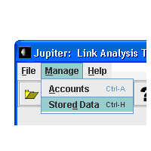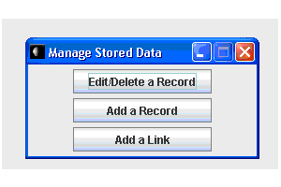
Add a Record:

Important Note: Prior to adding any records in the database, a search should be initiated on the data via a Link Analysis. This will minimize duplicate record entries.

- Step 1: Click “Manage”
- Step 2: Click “Stored Data”
- Step 3: Click “Add a Record”

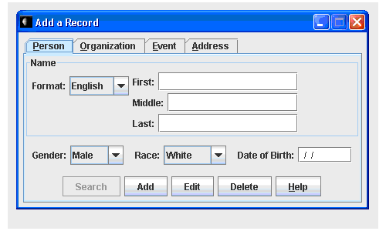

Person

A Person in Jupiter is represented by the following data:

- Name: English, Arabic, Hispanic or Alias
- Gender: Male or Female
- Race: White, Black, Hispanic, Indian, Asian or Unknown
- Date of Birth: 00/00/0000

Person: Names

Typical user interfaces contain a data entry view for entering information about people. Jupiter is designed to allow a more internationalized version of data entry, specifically, with respect to the entering of a person’s name. The standard or English format for entering a Person’s name is:

- Name 1 is the individual's first name
- Name 2 is the name of the individual's middle name
- Name 3 is the name of the individual's family name

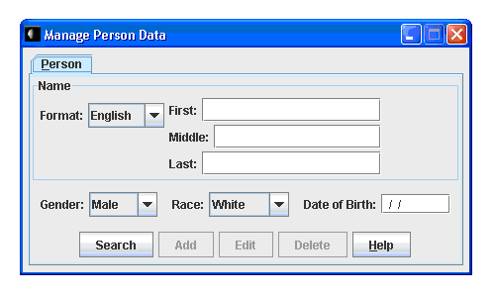
Person: Names

Often times, a Person’s name does not conform to this standard format. This leads to confusion on how to “force” a person’s name into the “standard” naming format. It also leads to inaccurate data that could be important in a complex criminal investigation (such as Terrorism).

For example, In Spanish-speaking countries, Hispanic people normally have at least two surnames (Last Names). One is inherited from the father, the other from the mother. Parents usually pass on to their children the name they inherited from their father, but this is not mandatory. The father's surname is written before the mother's surname (although there are occasional exceptions to this rule). Usually, the name of the father is put before the name of the mother. Hispanic name typically have up to four names:

- Name 1 is the individual's first name
- Name 2 is the name of the individual's father
- Name 3 is the name of the individual's mother (maiden name)

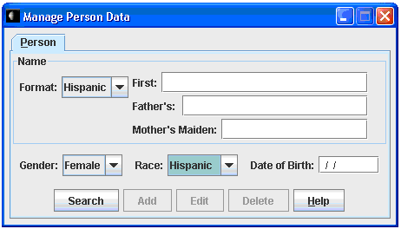
Person: Names

Arabic names are based on a long naming system. Most Arabs do not simply have a First, Middle and Last Name. Rather, Arabs have a full chain of names. This system is in use throughout the Arab world. Arabic names typically have up to four names:

- Name 1 is the individual's first name
- Name 2 is the name of the individual's father
- Name 3 is the name of the individual's grandfather
- Name 4 is the individual's family name

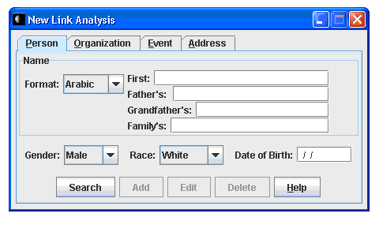

Person: Names

An Alias is stored as a Person’s name in Jupiter when a Person’s name is either unknown or the Person is known only by a “street name” or “nickname”.

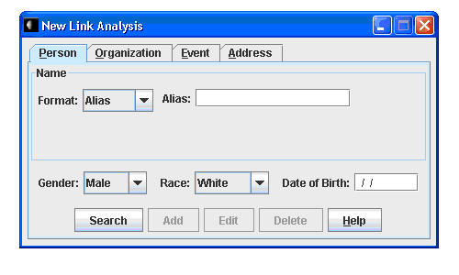

Person: Gender

Jupiter uses the Encyclopedia Britannica definition to identify a Person’s Gender. Gender identity is decided by the user’s view of the subject as being:

- Male
- Female

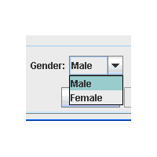
Person: Race
Jupiter uses the Race of a Person as defined by the United States Census Bureau and the Federal Office of Management and Budget (OMB). Race is an identification data item in which the user chooses the race with which they most closely identify the subject as belonging. The categories represent a social-political construct designed for the race they consider the subject to be and generally reflects a social definition of race recognized in the United States.
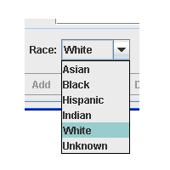
- White refers to people having origins in any of the original peoples of Europe, the Middle East, or North Africa. It includes people such as Irish, German, Italian, Persian, British, Assyrian, Iraqi, Near Easterner, Arab, or Polish.
- Black or African American refers to people having origins in any of the Black racial groups of Africa. It includes people such as African American, Afro American, Kenyan, Jamaican, Caribbean-American, Nigerian, or Haitian.
- Hispanic is one of several terms of ethnicity employed to categorize any person, of any racial background, of any country and of any religion who has at least one ancestor from the people of Spain or Spanish-speaking Latin America, whether or not the person has Spanish ancestry.
- Indian or American Indian and Alaska Native (AIAN) refer to people having origins in any of the original peoples of North and South America (including Central America), and who maintain tribal affiliation or community attachment.
- Asian refers to people having origins in any of the original peoples of the Far East, Southeast Asia, or the Indian subcontinent including, for example, Bangladesh, Cambodia, China, Pakistan, India, Japan, Korea, Malaysia, the Philippines, Taiwan, Thailand, and Vietnam. It includes "Asian Indian," "Chinese", "Filipino", "Korean", "Japanese", "Taiwanese", "Vietnamese", and "Other Asian".
- Unknown refers to any individual to whom their ancestry is unknown or undetermined. It may also include but not be limited to Native Hawaiian and Other Pacific Islander (NHPI) having origins in any of the original peoples of Hawaii, Guam, Samoa, or other Pacific Islands.

Person: Date of Birth

The default format for a Person’s birth date in Jupiter is month/date/year or MM/DD/YYYY. However, future versions of Jupiter will incorporate a locale specific date field and will continue to use the default format for the United States locale.


Organization

Jupiter stores only the name of an Organization. The Organization Name is limited to 50 characters. Notations for a specific Organization can be linked by the use of a Note.

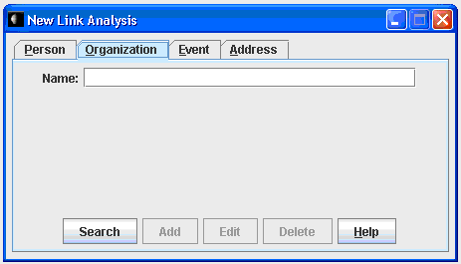

Event

Jupiter stores data related to specific Events. An Event consists of:

- Date of the Event
- Event Title: An Event title is limited to 30 characters. Examples, Drug Deal, Oklahoma City Bombing, 4th Street Shooting
- Event Description: A brief description of the event limited to 50 characters.

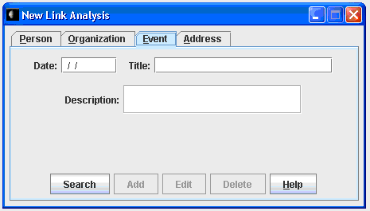

Address

Jupiter stores Addresses that include the fields:

- Country: The country where the address is located.
- Street: The street address or mailing address specific to a particular location. A Street is limited to 30 characters.
- City: The municipality, township, village or borough where the street address is located. A City is limited to 30 characters.
- State: The state, region, province or other sub national entity. A State is limited to 30 characters.
- Zip code: A postal code (known in various countries as a post code, postcode, or ZIP code) is a series of letters and/or digits appended to a postal address for the purpose of sorting mail. Although a zip code in the United States is only 5 characters in length, due to International considerations, a zip code in Jupiter is limited to 30 characters.

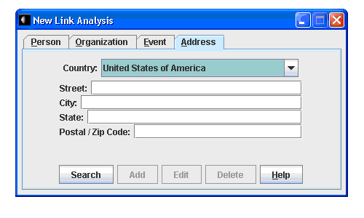

Phone

A Phone in Jupiter is the phone number to which a particular telephone or wireless phone is assigned. Jupiter uses the default United States phone number format of “(Area code) prefix-subscriber” or “(###) ### - ####” to store a Phone number. Plans to include phone number formats of other countries will be included in future versions of Jupiter.

Phone Call

Jupiter stores data related to Phone Calls to and from a particular Phone. This data can be used for analysis of phone usage pertaining to a particular Phone. The data stored for a Phone Call includes:

- Phone Call From:
- Country:
- Phone number:
- Phone Call To:
- Country:
- Phone number:
- Phone Call date and time:
- Phone Call duration:

Typically, Phone records are obtained in digital format. The file format of a digital Phone record is usually in the form of a comma-separated values file or a .CSV file. It is a very simple data file format that is supported by almost all spreadsheet software such as Excel.

A typical digital Phone record can contain a large amount of data. Therefore, future versions of Jupiter will allow the import of data from a .CSV file, since manual data entry of large phone records would be quite inefficient.

Note

Jupiter uses a Note to attach unique information to a particular Entity. A Note is limited to 50 characters. A Note can contain information such as:

- Safety notations related to a particular Person. For example, “Known to always carry a firearm”.
- Information for a particular Phone. For example, “Subscriber James Smith”, “User Billy Smith”, or “Service Provider U.S. Cellular”.

Graph

The Graph in Jupiter is used to illustrate relationships between entities. The Graph displays the subject of a Link Analysis in the center and then plots the links around the subject. Lines are then connected from the subject to each of the links. In future versions, Jupiter will be able to show how a subject’s links are related to other links. The Graph is at its early stages of development. A user will also be able to save the Graph on the local computer and print the Graph.

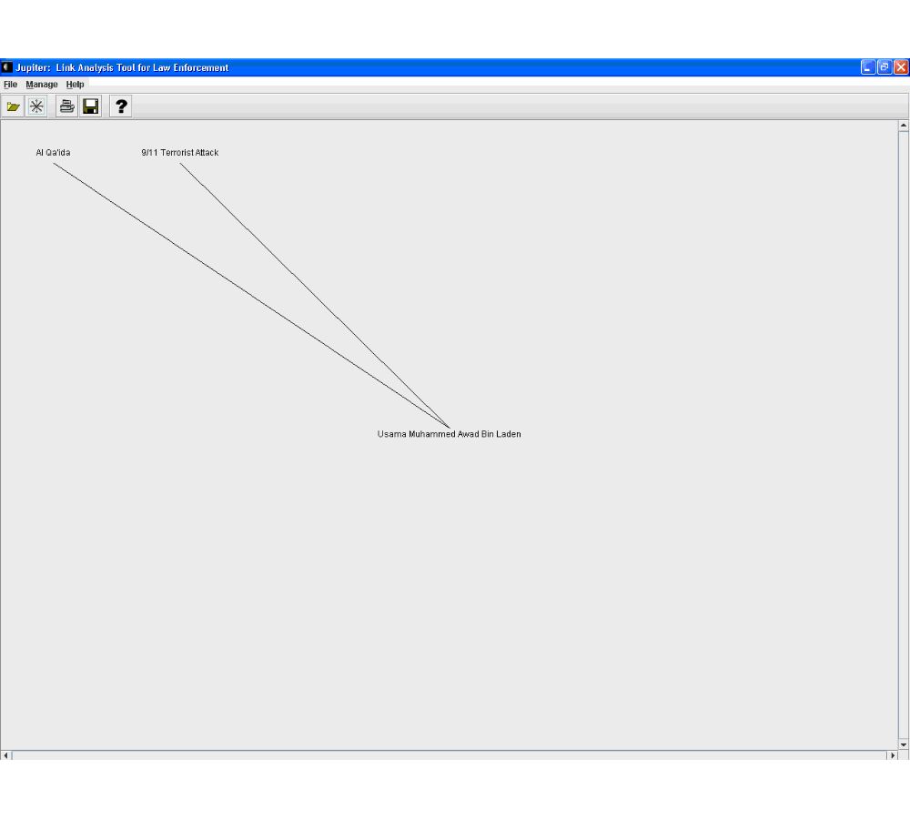

Report

The Report generated by Jupiter is a non-editable textual representation of the Link Analysis. A Jupiter Report is viewed in the following format:

- Title: Link Analysis of:
- Entity Information:
- Person: Name, Gender, Race, Date of Birth
- Organization Name
- Address: Street, City, State, Zip code, Country
- Event: Date, Title, Description
- Phone: Phone number
- Phone Call: Phone From, Phone To, Call Date and Time, Duration
- Title: Link(s):
- Note:
- Address:
- Phone:
- Person:
- Event:
- Phone Call:

A Report can be saved to the local computer and printed.

